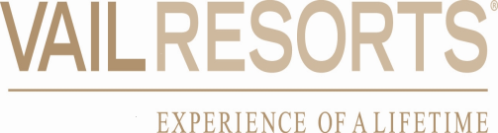

Dear Name,
On behalf of The Vail Corporation (“Company”), I am very pleased to communicate your promotion to the position of New Title.
Your promotion consists of the following compensation components which are subject to their applicable terms and conditions, and except as specifically stated below, all of your current terms and conditions of employment remain unchanged.

Component | Amount
FY19 Base Wage | $
Management Incentive Program (MIP) Target % | %
Management Incentive Program (MIP) Target $ | $
Total Estimated Target Compensation | $

We are eager to see you continue to apply your expertise towards the Vail Resorts vision to “Re-Imagine the Mountain Experience Around the World” and look forward to working with you in your new role.

As a reminder, this letter is a summary of the new terms of your employment in your new role, and is not a contract for employment or a guarantee of continuing employment with Vail Resorts. Your employment with the Company is “at-will” meaning that, just as you may end your employment at any time, the Company may terminate your employment with or without notice or cause. And, unless otherwise noted above, the other terms and conditions of your employment, including benefits eligibility, remain unchanged.

Sincerely,

Manager Name

